INSTALLATION OF OPENSTACK PACKSTACK

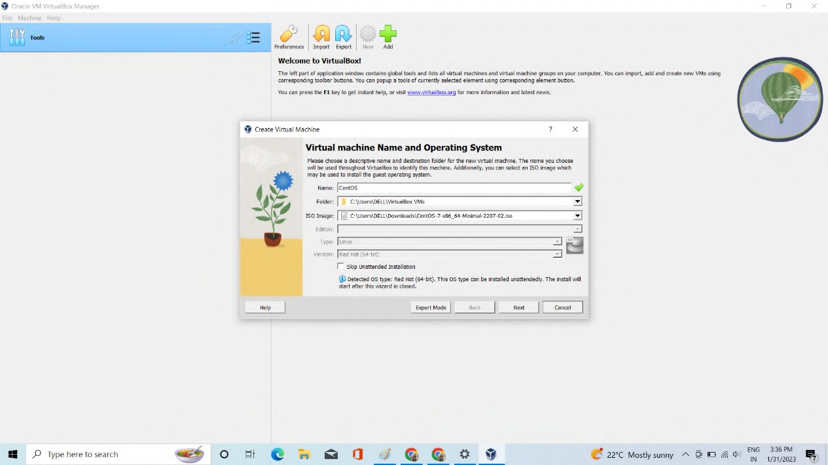Name:- Arpita Kasaudhan SAP ID :- 500088021 BATCH:- CCVT B4

Firstly we need to download the iso file from the centos.org.

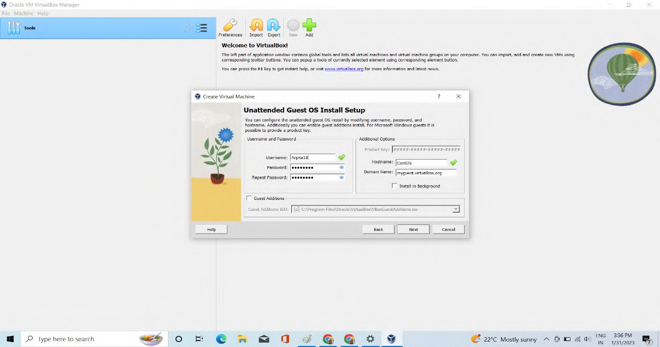

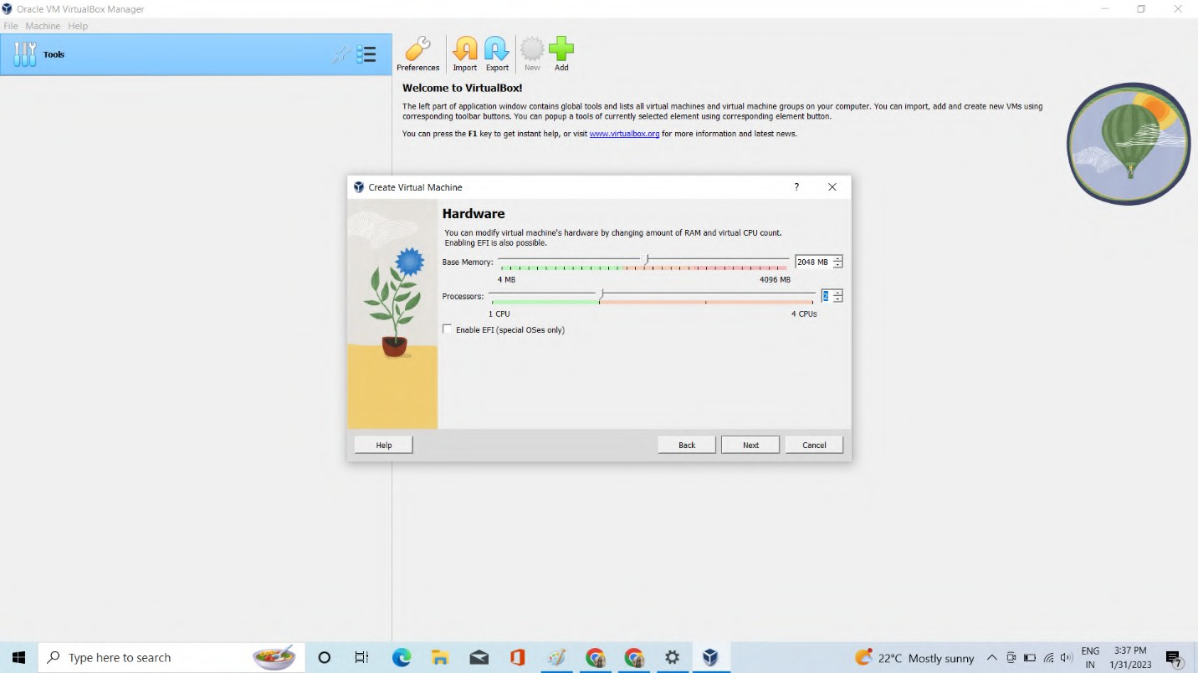

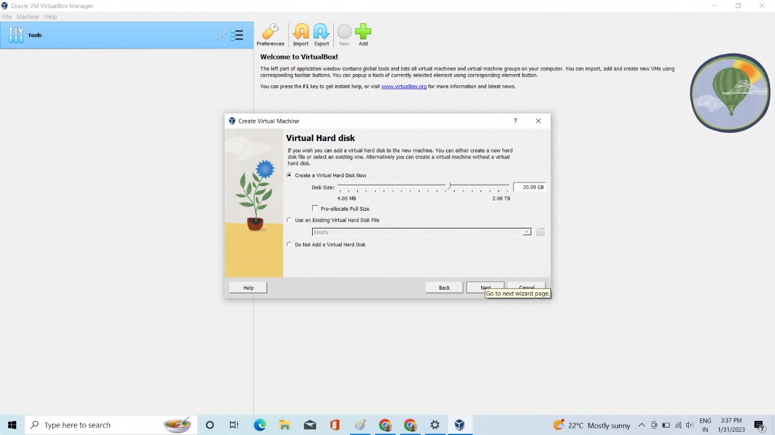

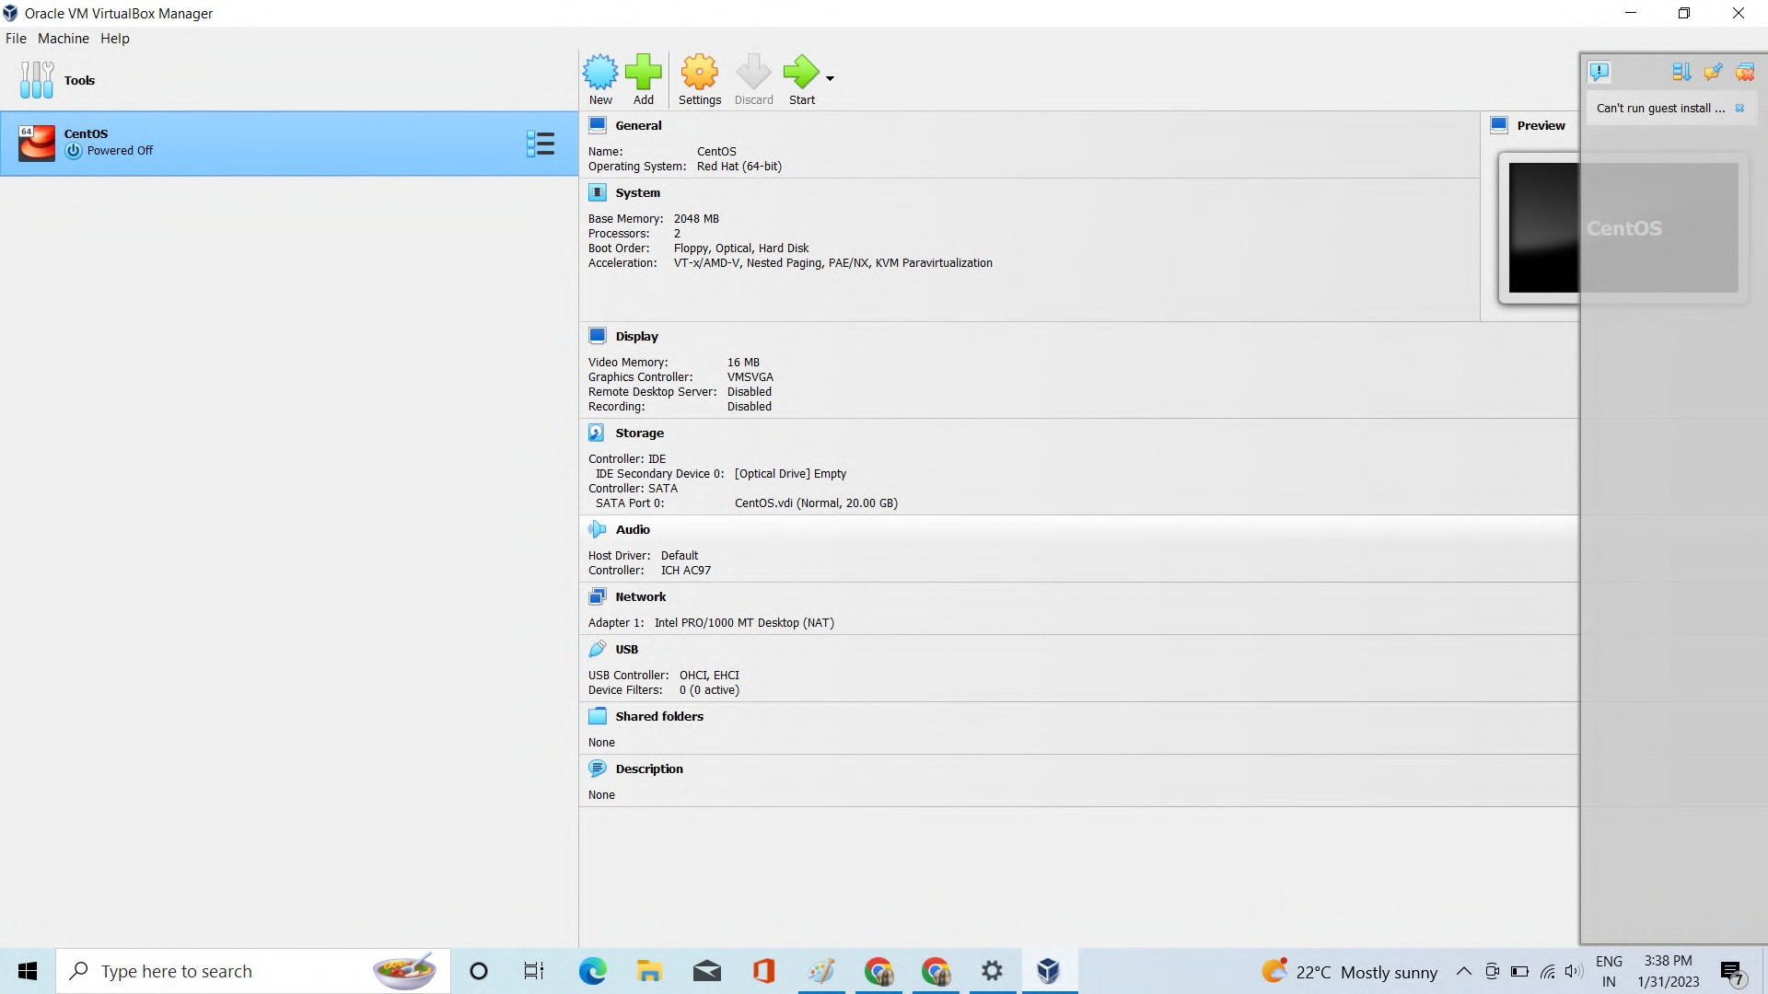



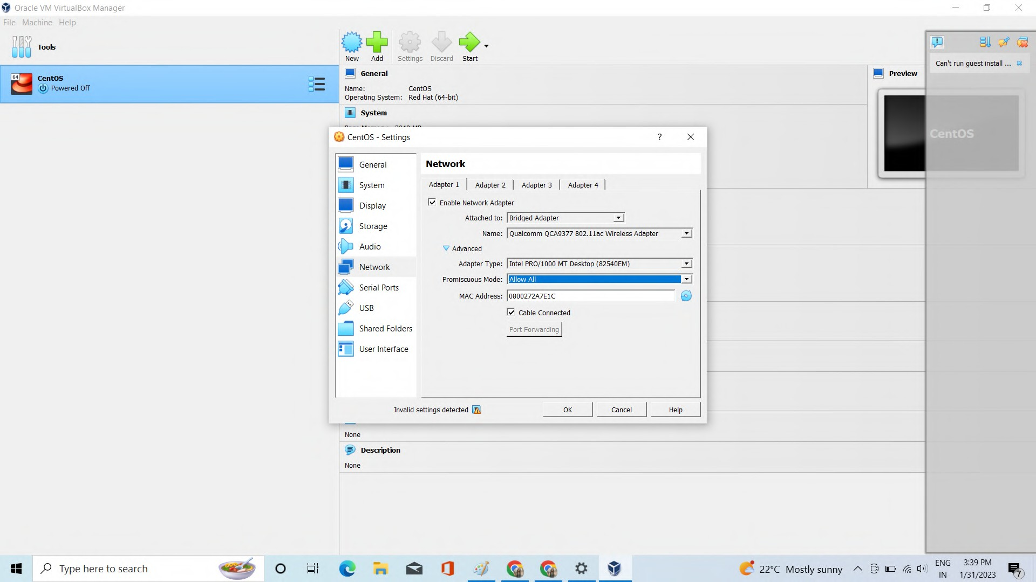

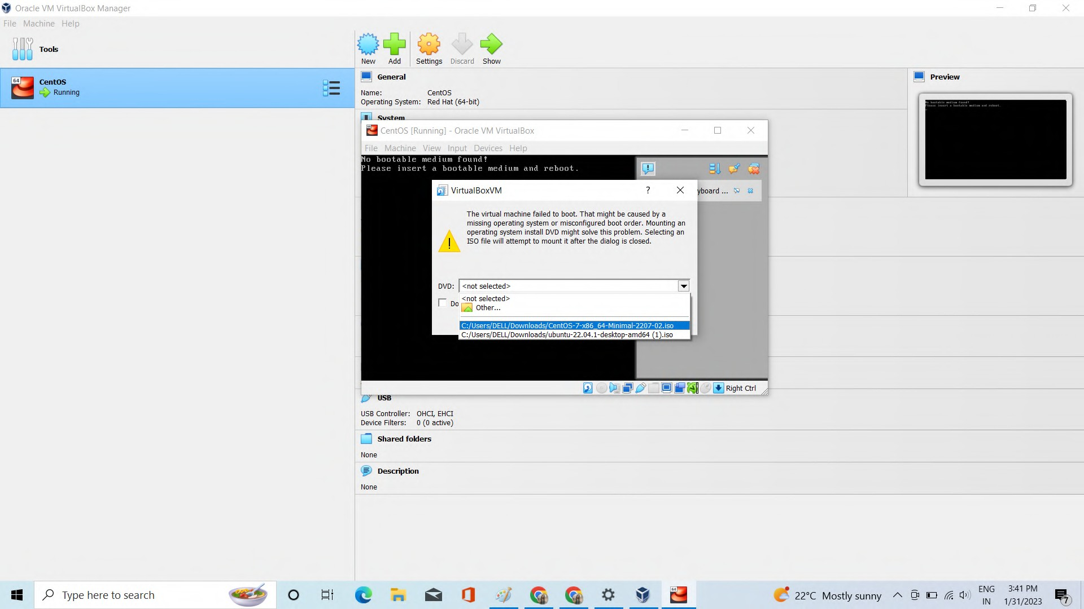

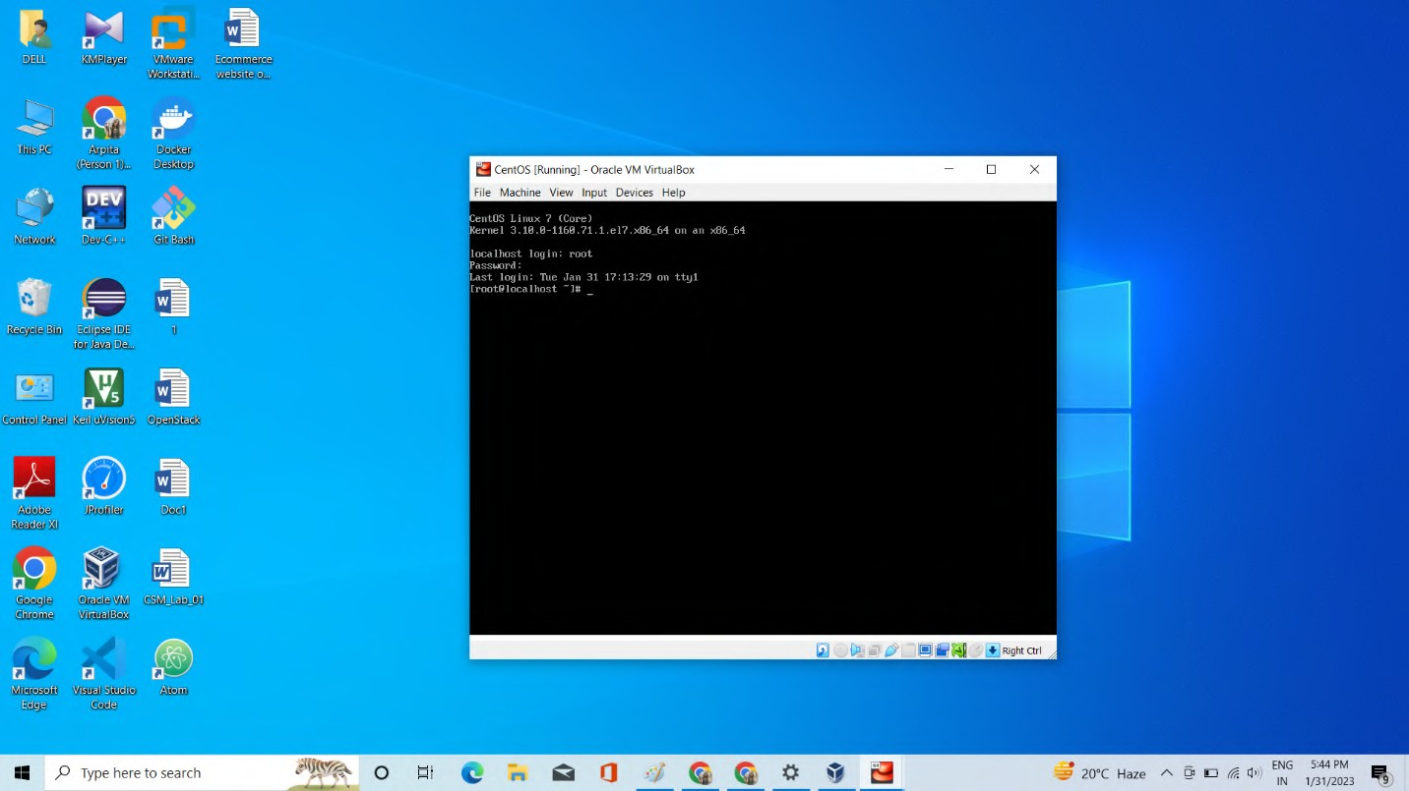

Perform the “**cat /etc/redhat-release command**” command

this command is basically used to display the version of centos operating system installs on the machine.

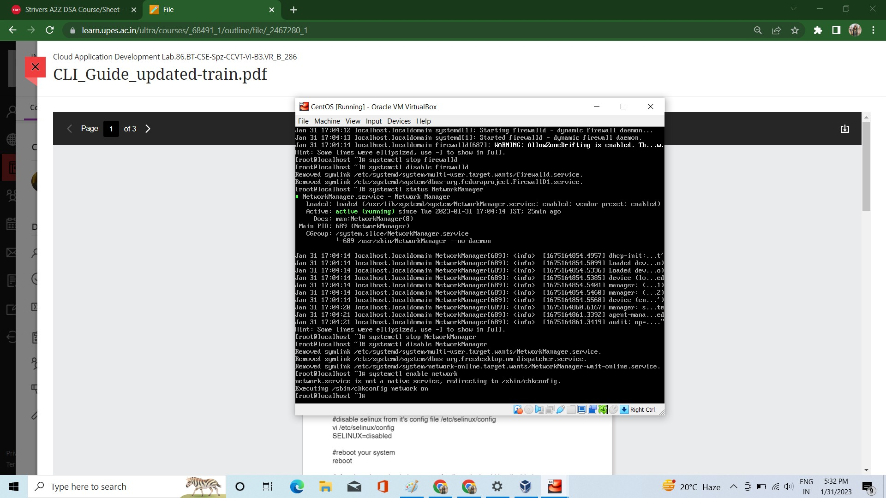

# Perform the “systemctl status ﬁrewalld, systemctl stop ﬁrewalld, systemctl disable ﬁrewalld” commands

The firewalld service's status is shown using the systemctl status firewalld command on a CentOS system.

The systemctl disable firewalld command prevents the firewalld service from beginning at boot, while the systemctl stop firewalld command terminates the firewalld service.



# Perform the “systemctl status NetworkManager, systemctl stop NetworkManager, systemctl disable NetworkManager” commands

The NetworkManager service status on a system is shown by the systemctl status NetworkManager command.

The NetworkManager service is terminated with the systemctl stop NetworkManager command, and

The NetworkManager service cannot start at boot when the systemctl disable NetworkManager command is used.

# Perform the “systemctl enable Network, systemctl disable Network” commands

On a CentOS system, the Network service is enabled with the systemctl enable Network command.

The Network service on the system is turned off using the systemctl disable Network command, preventing it from beginning when the system boots.

The Network service, which is in charge of configuring and managing network connections on the system, is managed by means of these instructions.

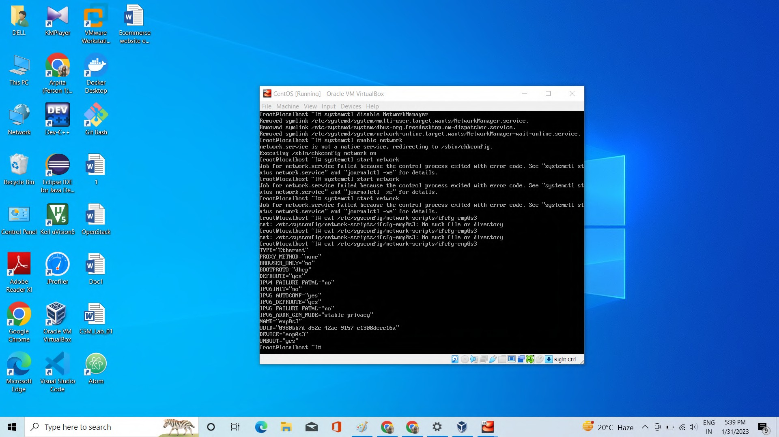

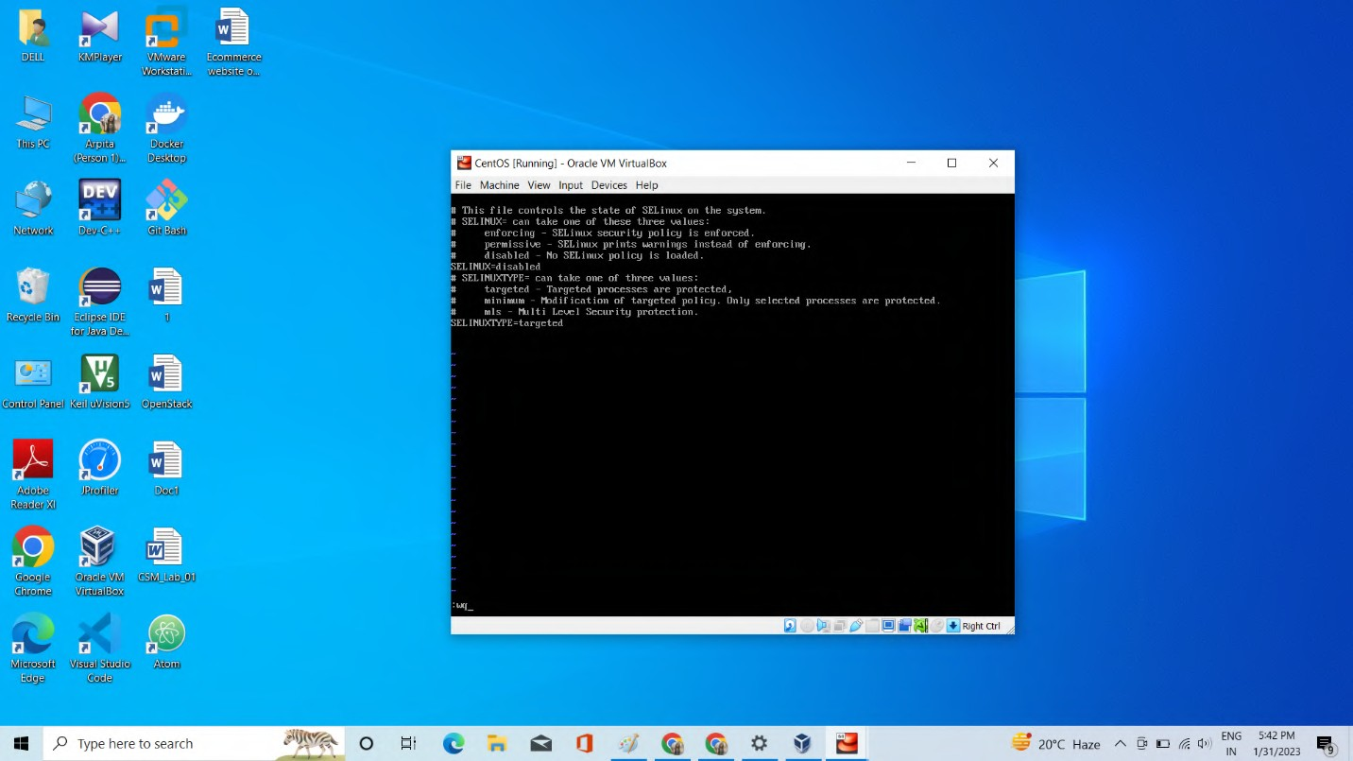

# Perform the “vi /etc/environment LANG=en_US.utf-8LC_ALL=en_US.utf-8”

On a system similar to Unix, the vi /etc/environment command opens the /etc/environment file in the VI editor. Environment variables for each user on the system are configured in the /etc/environment file. Numerous programmes and services can use these environment variables to define the system setup.

Users can create and edit text files using the VI editor, a terminal-based text editor.The vi

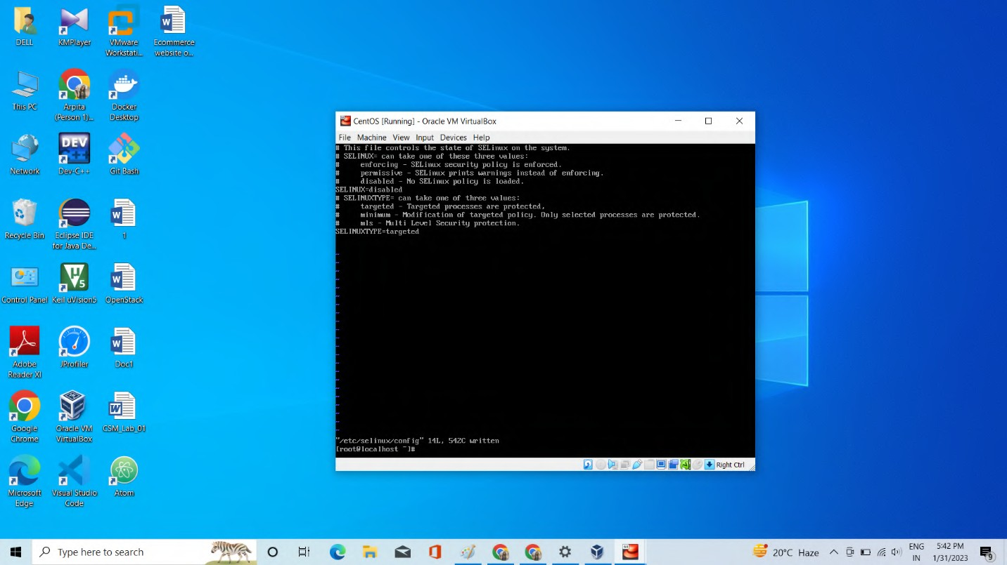command can be used to open and edit text files on the system.





Perform the “**cat /etc/sysconﬁg/network-scripts/ifcfg-enp0s3**” command

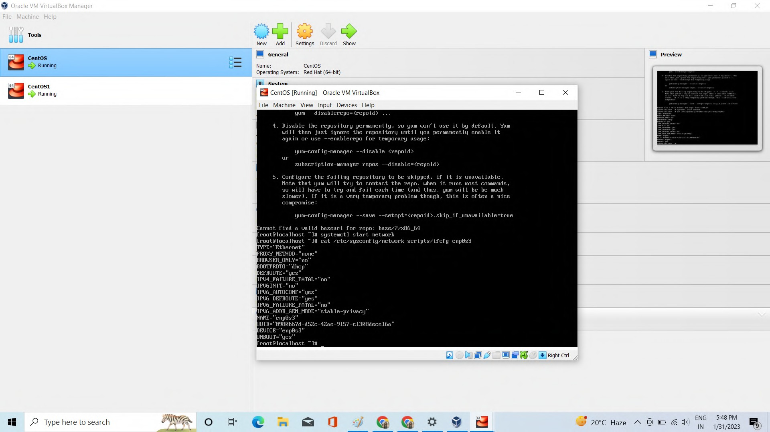

Perform the “**sudo yum install -y centos-release-openstack-train**” command.

The "centos-release-openstack-train" package is installed on a CentOS system using the yum package management by the command sudo yum instal -y. Due to the fact that installing the package necessitates access to system resources that are generally secured, the sudo command is used to perform the command with administrative capabilities. By specifying the -y option, yum is instructed to proceed with the installation and assume that everything is well. The "centos-release-openstack-train" package gives the CentOS system the software repository details required to instal and administer the OpenStack software.

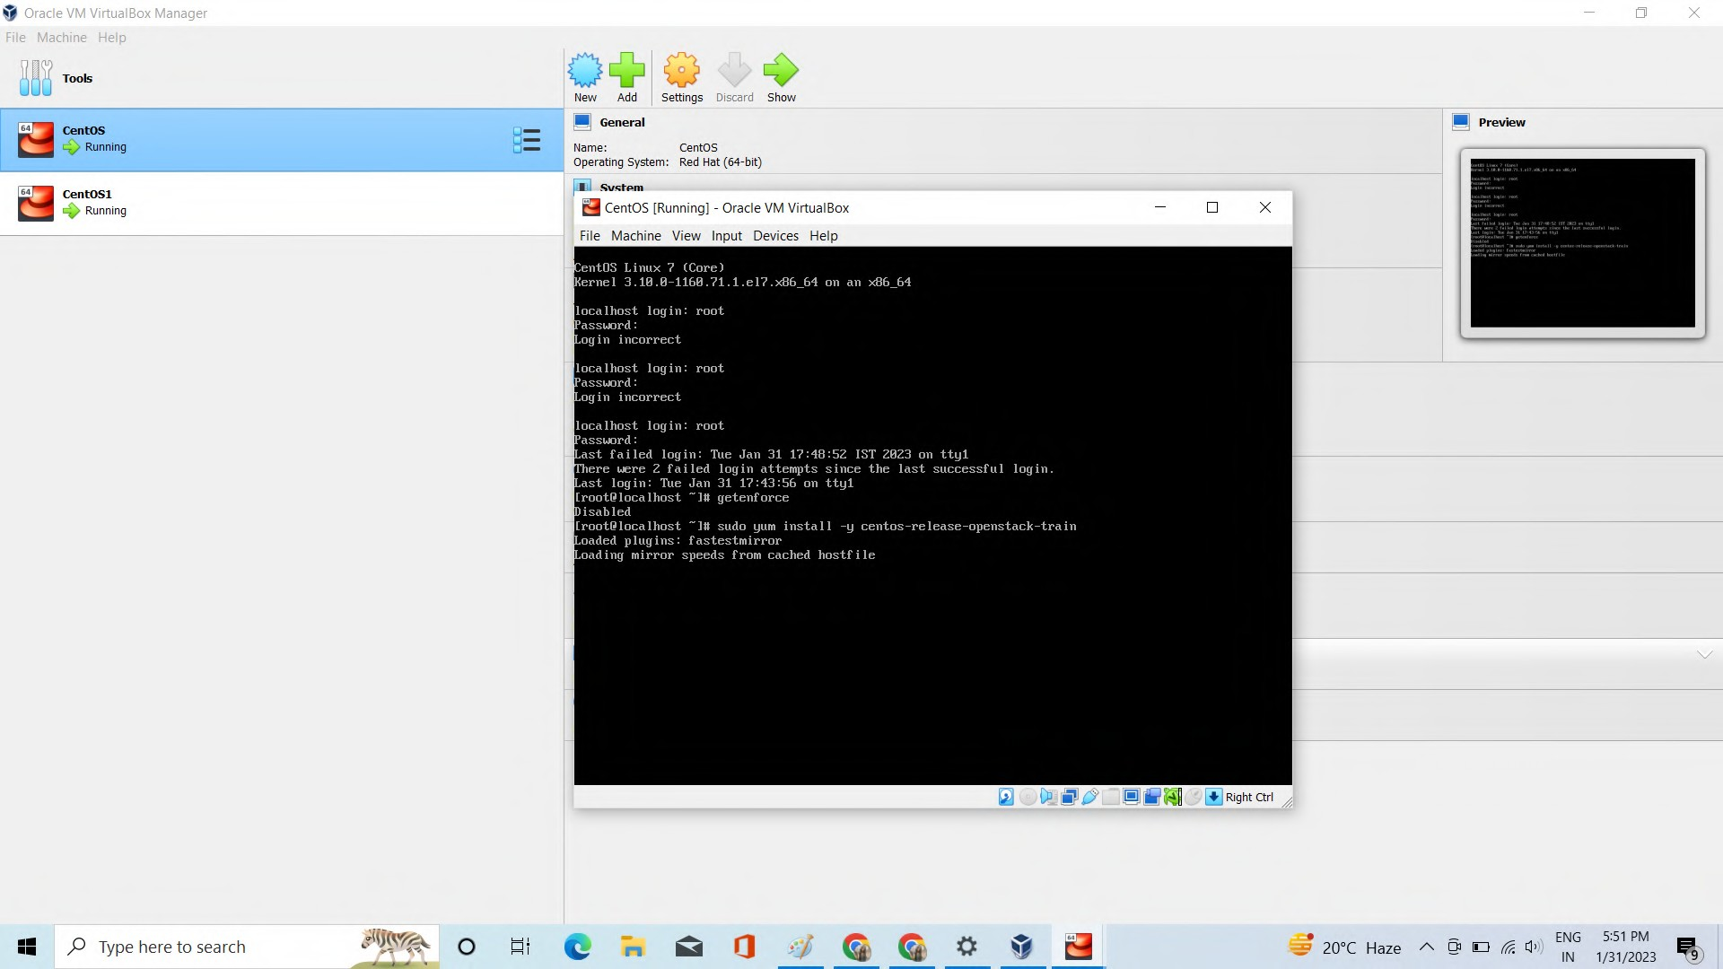

Perform the “**sudo yum install yum-utils**” command

The command sudo yum install yum-utils installs the "yum-utils" package on a CentOS

system using the yum package manager The "yum-utils" package provides a set of utilities that extend and enhance the functionality of the yum package manager.

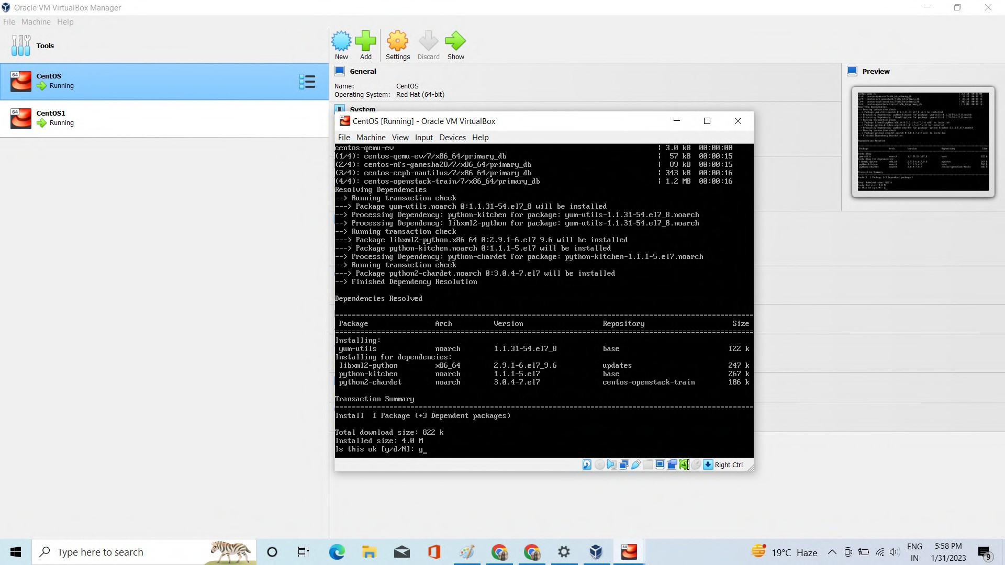

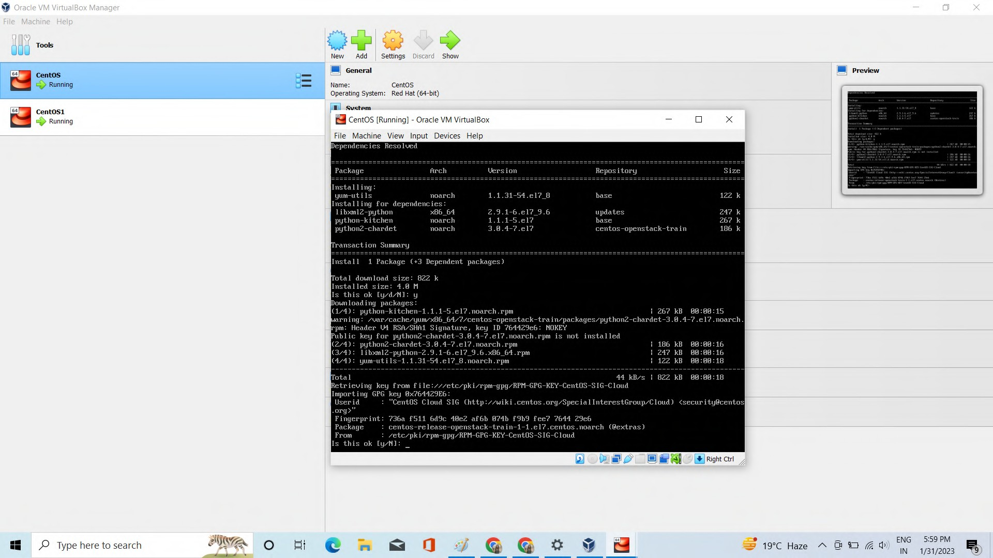

Perform the “**sudo yum-conﬁg-manager --enable openstack-train**” command

The OpenStack "train" repository, which offers the software packages required to instal and administer the OpenStack software on the system, is accessed by configuring the system with this command.

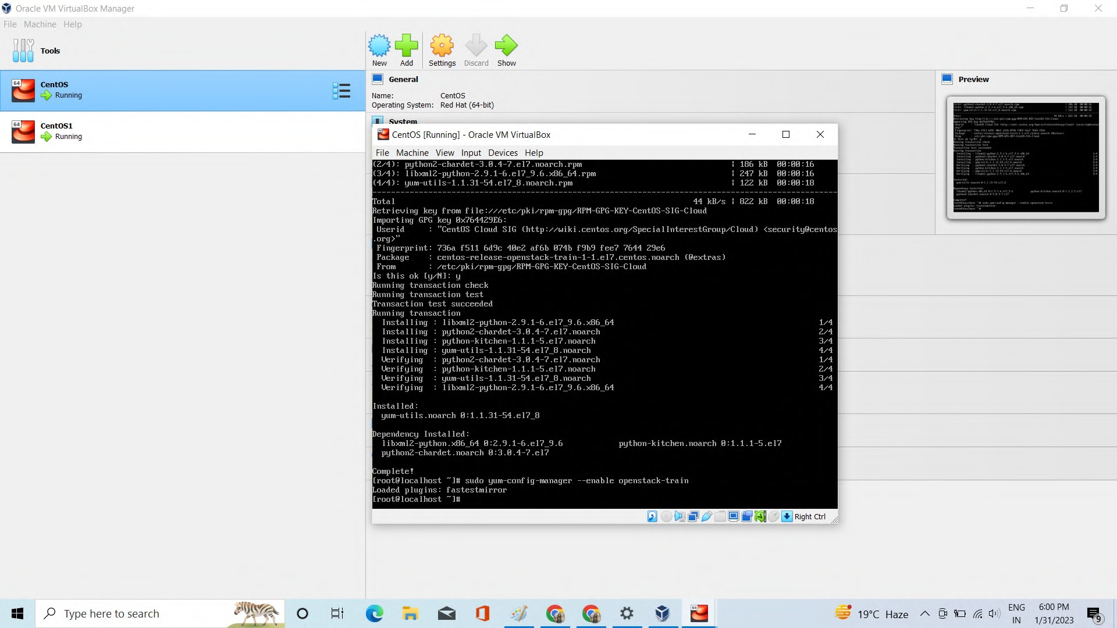

**“sudo yum update -y**” command

This command is used to keep the system's installed packages up-to-date and fix any security vulnerabilities or bugs that have been discovered. It's a good practice to regularly run the yum update command to ensure that the system is secure and has

the latest software updates.

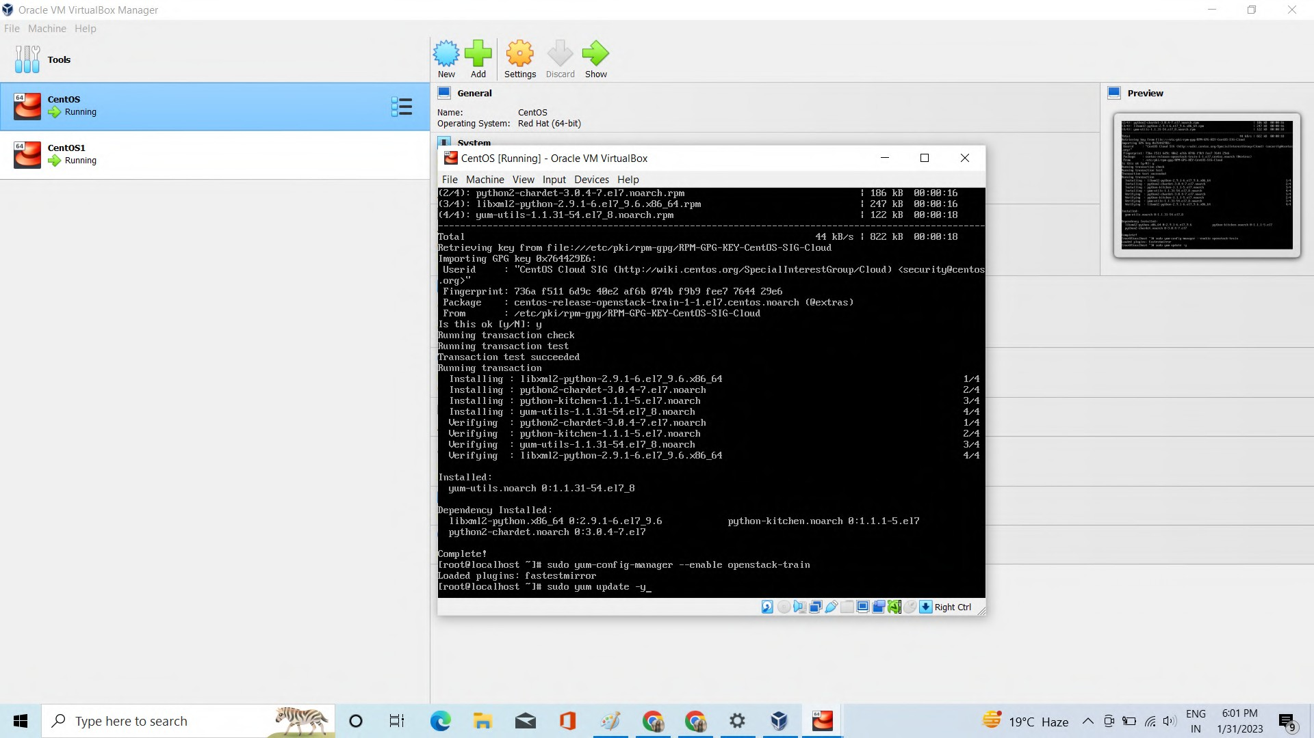

# “sudo yum install -y openstack-packstack” Command

The "openstack-packstack" package provides the "packstack" utility, which is used to deploy and manage OpenStack cloud computing environments. The "packstack" utility automates the process of installing and configuring OpenStack components, making it easier to set up and manage OpenStack deployments. By installing the "openstack- packstack" package, users can use the "packstack" utility to deploy and manage OpenStack environments on their systems.

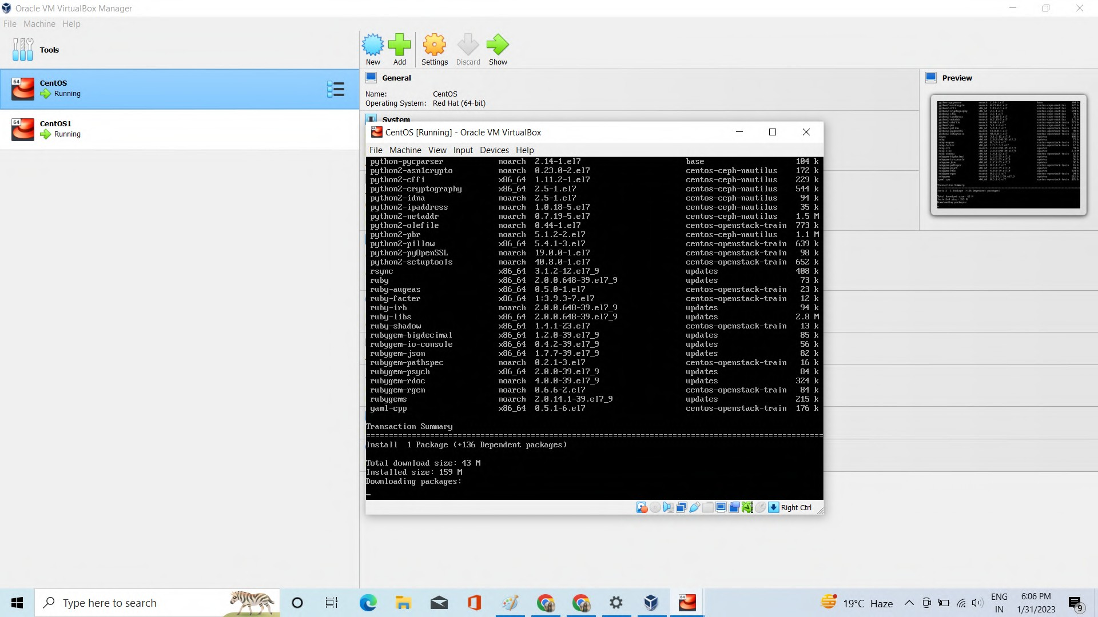

packstack --allinone --provision-demo=n --os-neutron-ovs-bridge-mappings=extnet:br- ex--os-neutron-ml2-mechanism-drivers=openvswitch --os-neutron-l2- agent=openvswitch --os-neutron-ovs-bridge-interfaces=br-ex:enp0s3 --os-neutron-ml2- type-drivers=vxlan,ﬂat--os-neutron-ml2-tenant-network-types=vxlan

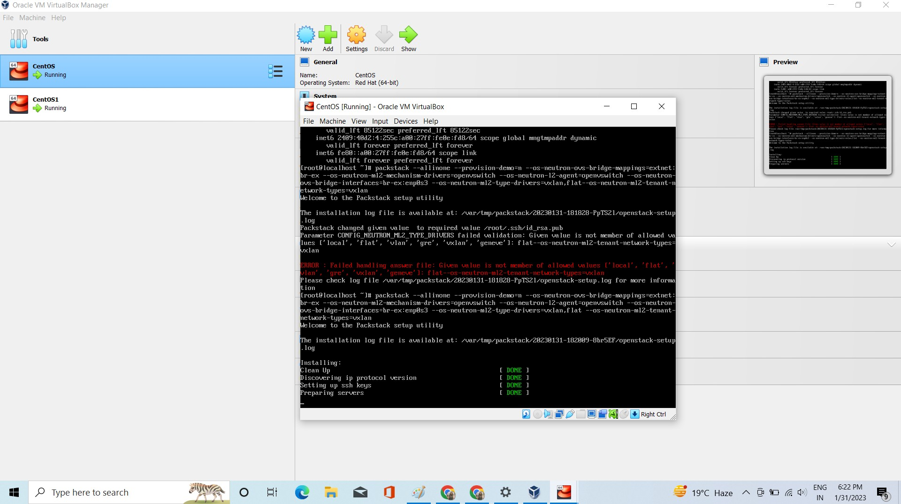

**“ip address show”** command

The command ip address show displays information about the network interfaces and their IP addresses on a CentOS system. The ip command is used to manage IP addresses and other network settings on the system.

